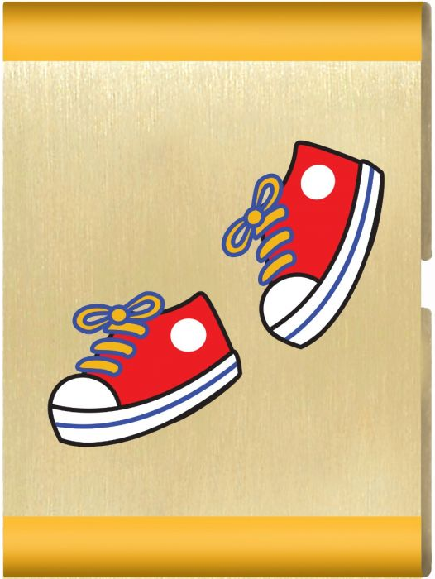
Fun on the Run
Parent and Leader Guidebook: pages 37-40
Lion Adventure Book: page 7
- Learn and demonstrate three exercise you can do each day.
- Have Lions make a nutritious snack for the den.
- Understand the importance of rest.
- Participate as a den in Jungle Field Day.

Materials
- Copies of Fun on the Run handout, one per adult
- Copy of Den Meeting Plan, one for leader(s)
- Name tags and Sharpie
- Copies of pack calendar
- Cub Scouts Poster Set with Scout Law, Scout Oath and Den Code of Conduct
(#621086 from Scout Shop)
- Blue tape or something to hang posters on wall

Optional
- Snack and water
- Activities for siblings (e.g., coloring books)

Activities
- Gathering: Red Light, Green Light – flag version:
- Red flag
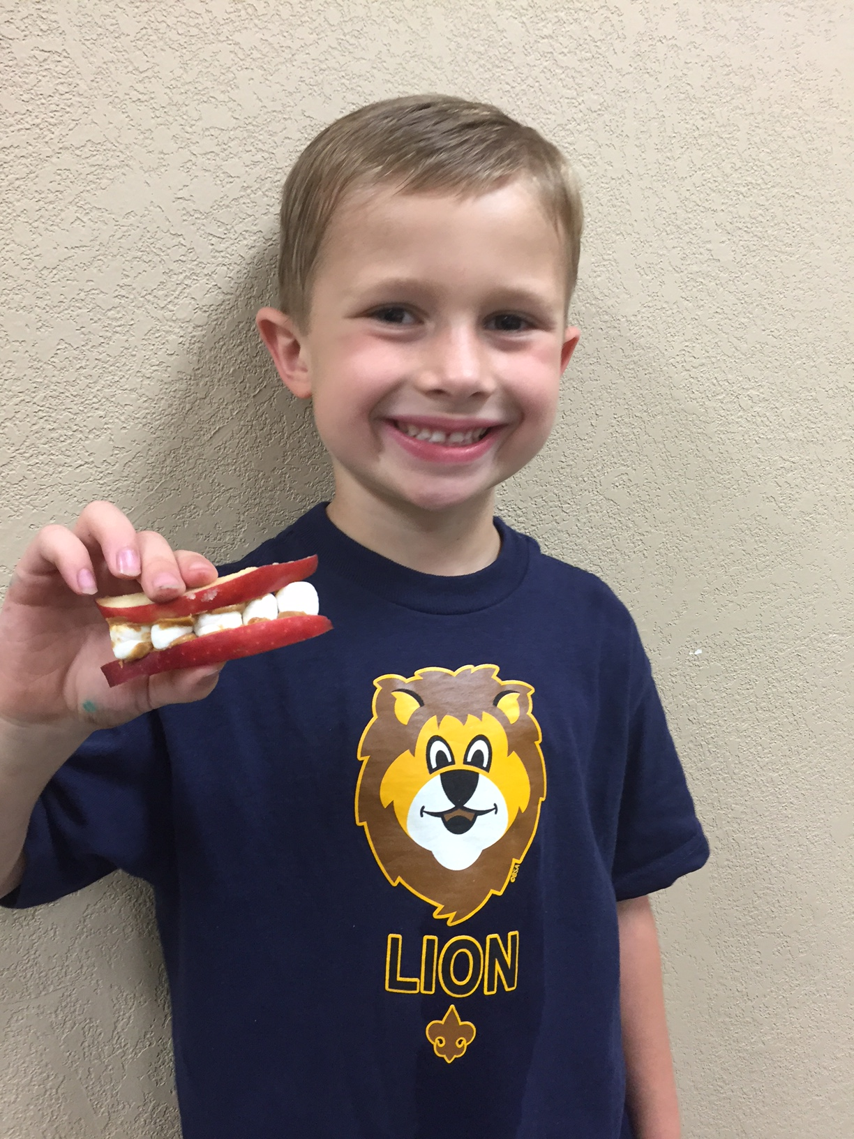
- Green flag
- Activity 1: Exercise
- Jump rope
- Activity 2: Nutritious Snack
- Nutritious Snack (see page 39). For example, trail mix, ants on a log, Lion’s teeth.
- Activity 3: Animal Match Game
- Cards with pictures of different animals
- Cards with sun or moon

- Jungle Field Day Activities:
- Crab walk: Start/finish line
- Balancing: bean bag, rope
- Weight: full soup cans
- Three-legged race: ribbon or streamer

Wrap Up Game
- Colored pencils, crayons or markers
- Few extra copies of Lion Adventure Book page 9 (for those who forget book)
Den Meeting Plan
Fun on the Run
Parent and Leader Guidebook: pages 37-40
Lion Adventure Book: page 7
- Learn and demonstrate three exercise you can do each day.
- Have Lions make a nutritious snack for the den.
- Understand the importance of rest.
- Participate as a den in Jungle Field Day.

Gathering
- Red Light, Green Light game – flag version (page 32)
- Game: Lion, May I (page 39)

Opening
- Pledge, Scout Oath, Scout Law

Activities
- Activity 1: Exercises
  - Basic exercises (jumping jacks, leap, hop, skip, jump)
  - Jump rope
  - Marching
  - Running
  - Jump Rope Chant
- Activity 2: Nutritious Snack
- Activity 3: Animal Match Game
- Jungle Field Day (page 40)
- Station 1 – Jumping Jacks
- Station 2 – Crab Walk
- Station 3 – Balancing (beanbag on head, walking on rope)
- Station 4 – Weights
- Station 5 – Three-legged race with adult partner

Wrap Up
- Lion Adventure Book, page 7
Fun on the Run

Head, Shoulders, Knees and Toes
Head, shoulders, knees, and toes, knees and toes,
Head, shoulders, knees, and toes, knees and toes,
Eyes and ears and mouth and nose,
Head, shoulders, knees, and toes, knees and toes!
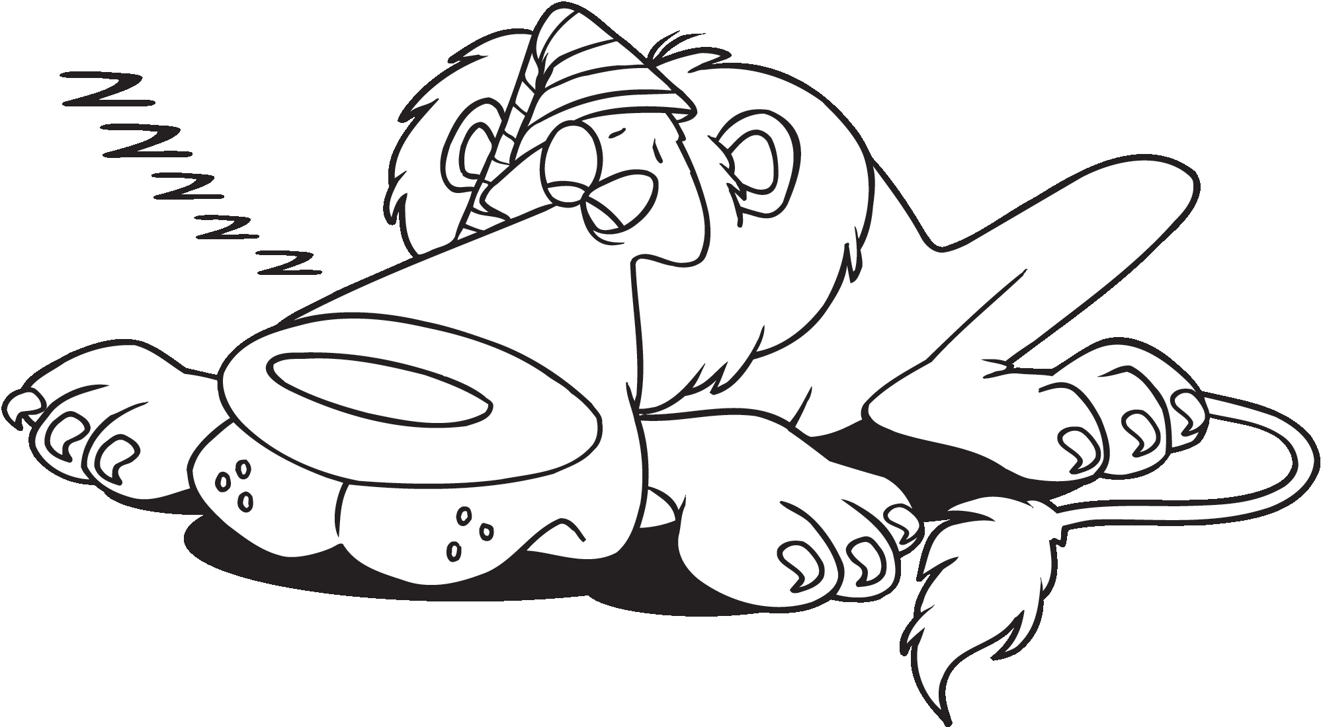
Scout Law
A Scout is trustworthy, loyal, helpful, friendly, courteous, kind, obedient, cheerful, thrifty, brave, clean, reverent.
Scout Oath
On my honor, I will do my best to do my duty to God and my country and to obey the Scout Law; to help other people at all times; to keep myself physically strong, mentally awake, and morally straight.
Jump Rope Chant
Lion, Lion, turn around.
Lion, Lion, touch the ground.
Lion, Lion, jump up high.
Lion, Lion, touch the sky.
Lion, Lion, reach down low.
Lion, Lion, touch your toe.
Upcoming Events

Dec 6 Den Meeting

Dec 20 Pack Meeting
(bring food to donate)

Jan 10 Den Meeting
TBD Outing

Feb 7 Den Meeting
Feb 24 Pinewood Derby
Feb 28 Pack Meeting
Pack 72
facebook.com/pack72tomball
pack72tomball.scoutlander.com
Orion District
www.orion.shac.org
facebook.com/orionbsa
Sam Houston Area Council
www.shac.org
facebook.com/shac.bsa
Name: _______________________

 | DIURNAL  (day time animals) |  |  | NOCTURNAL  (night time animals)

 | 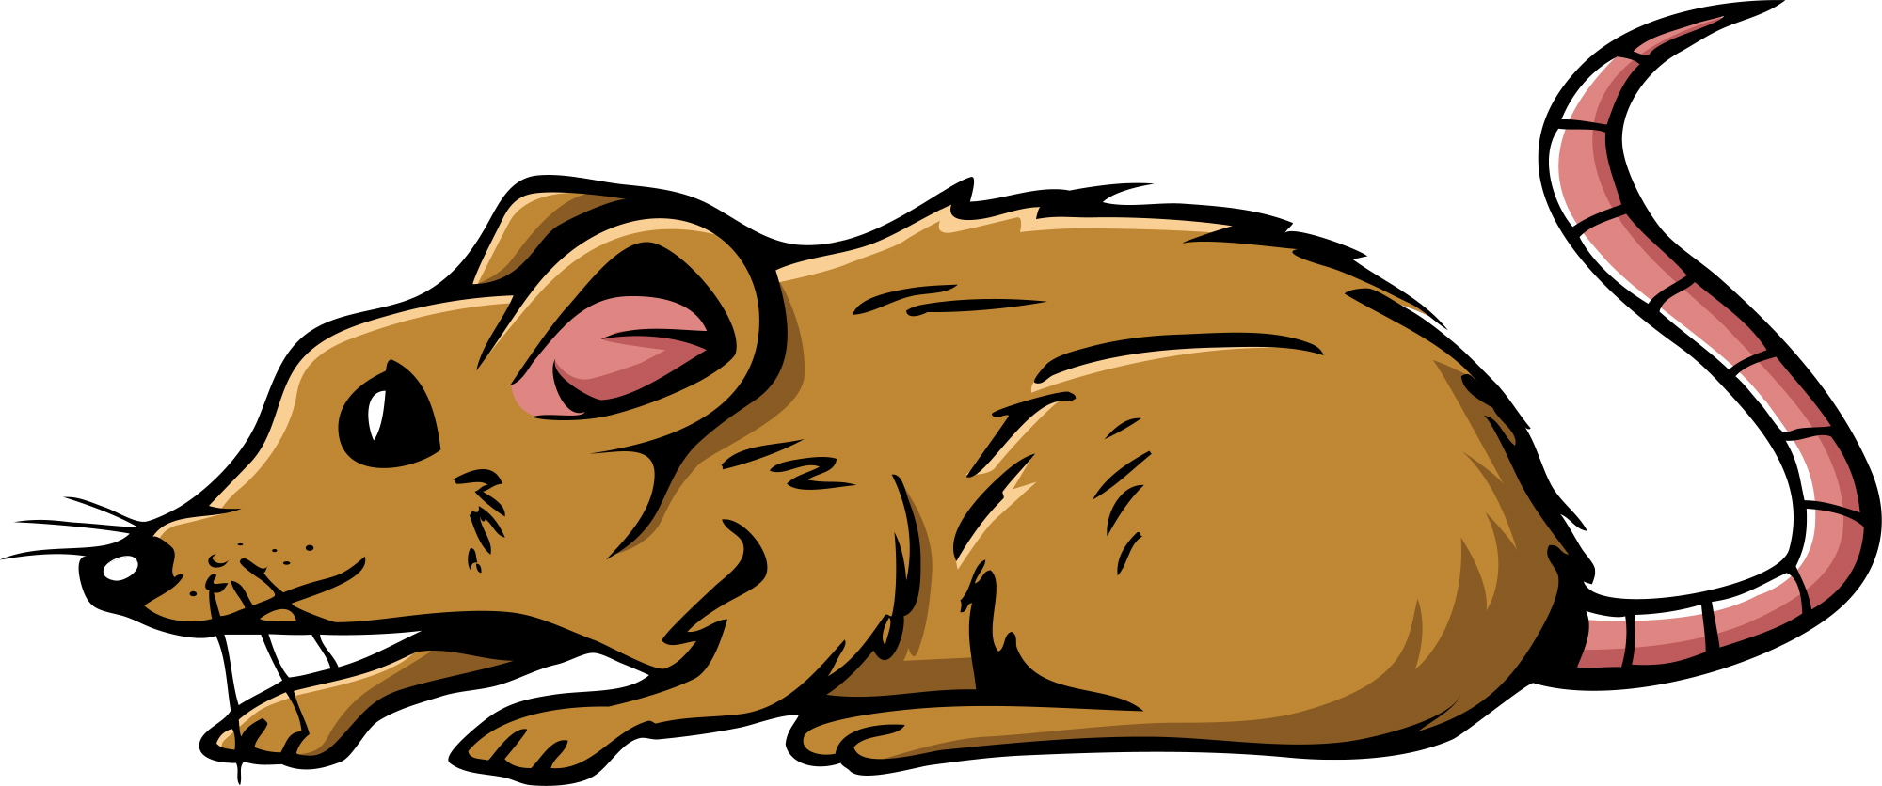 | 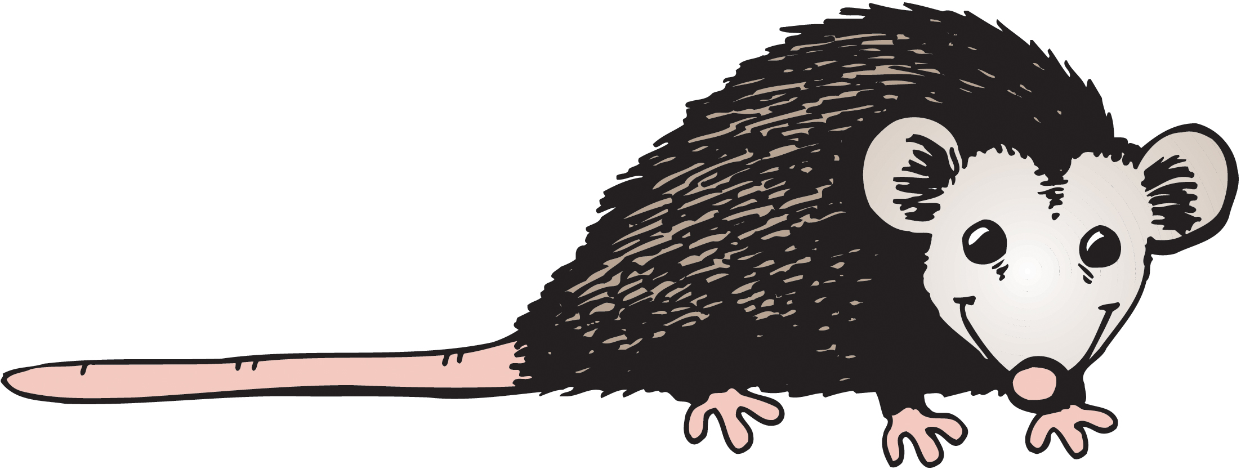
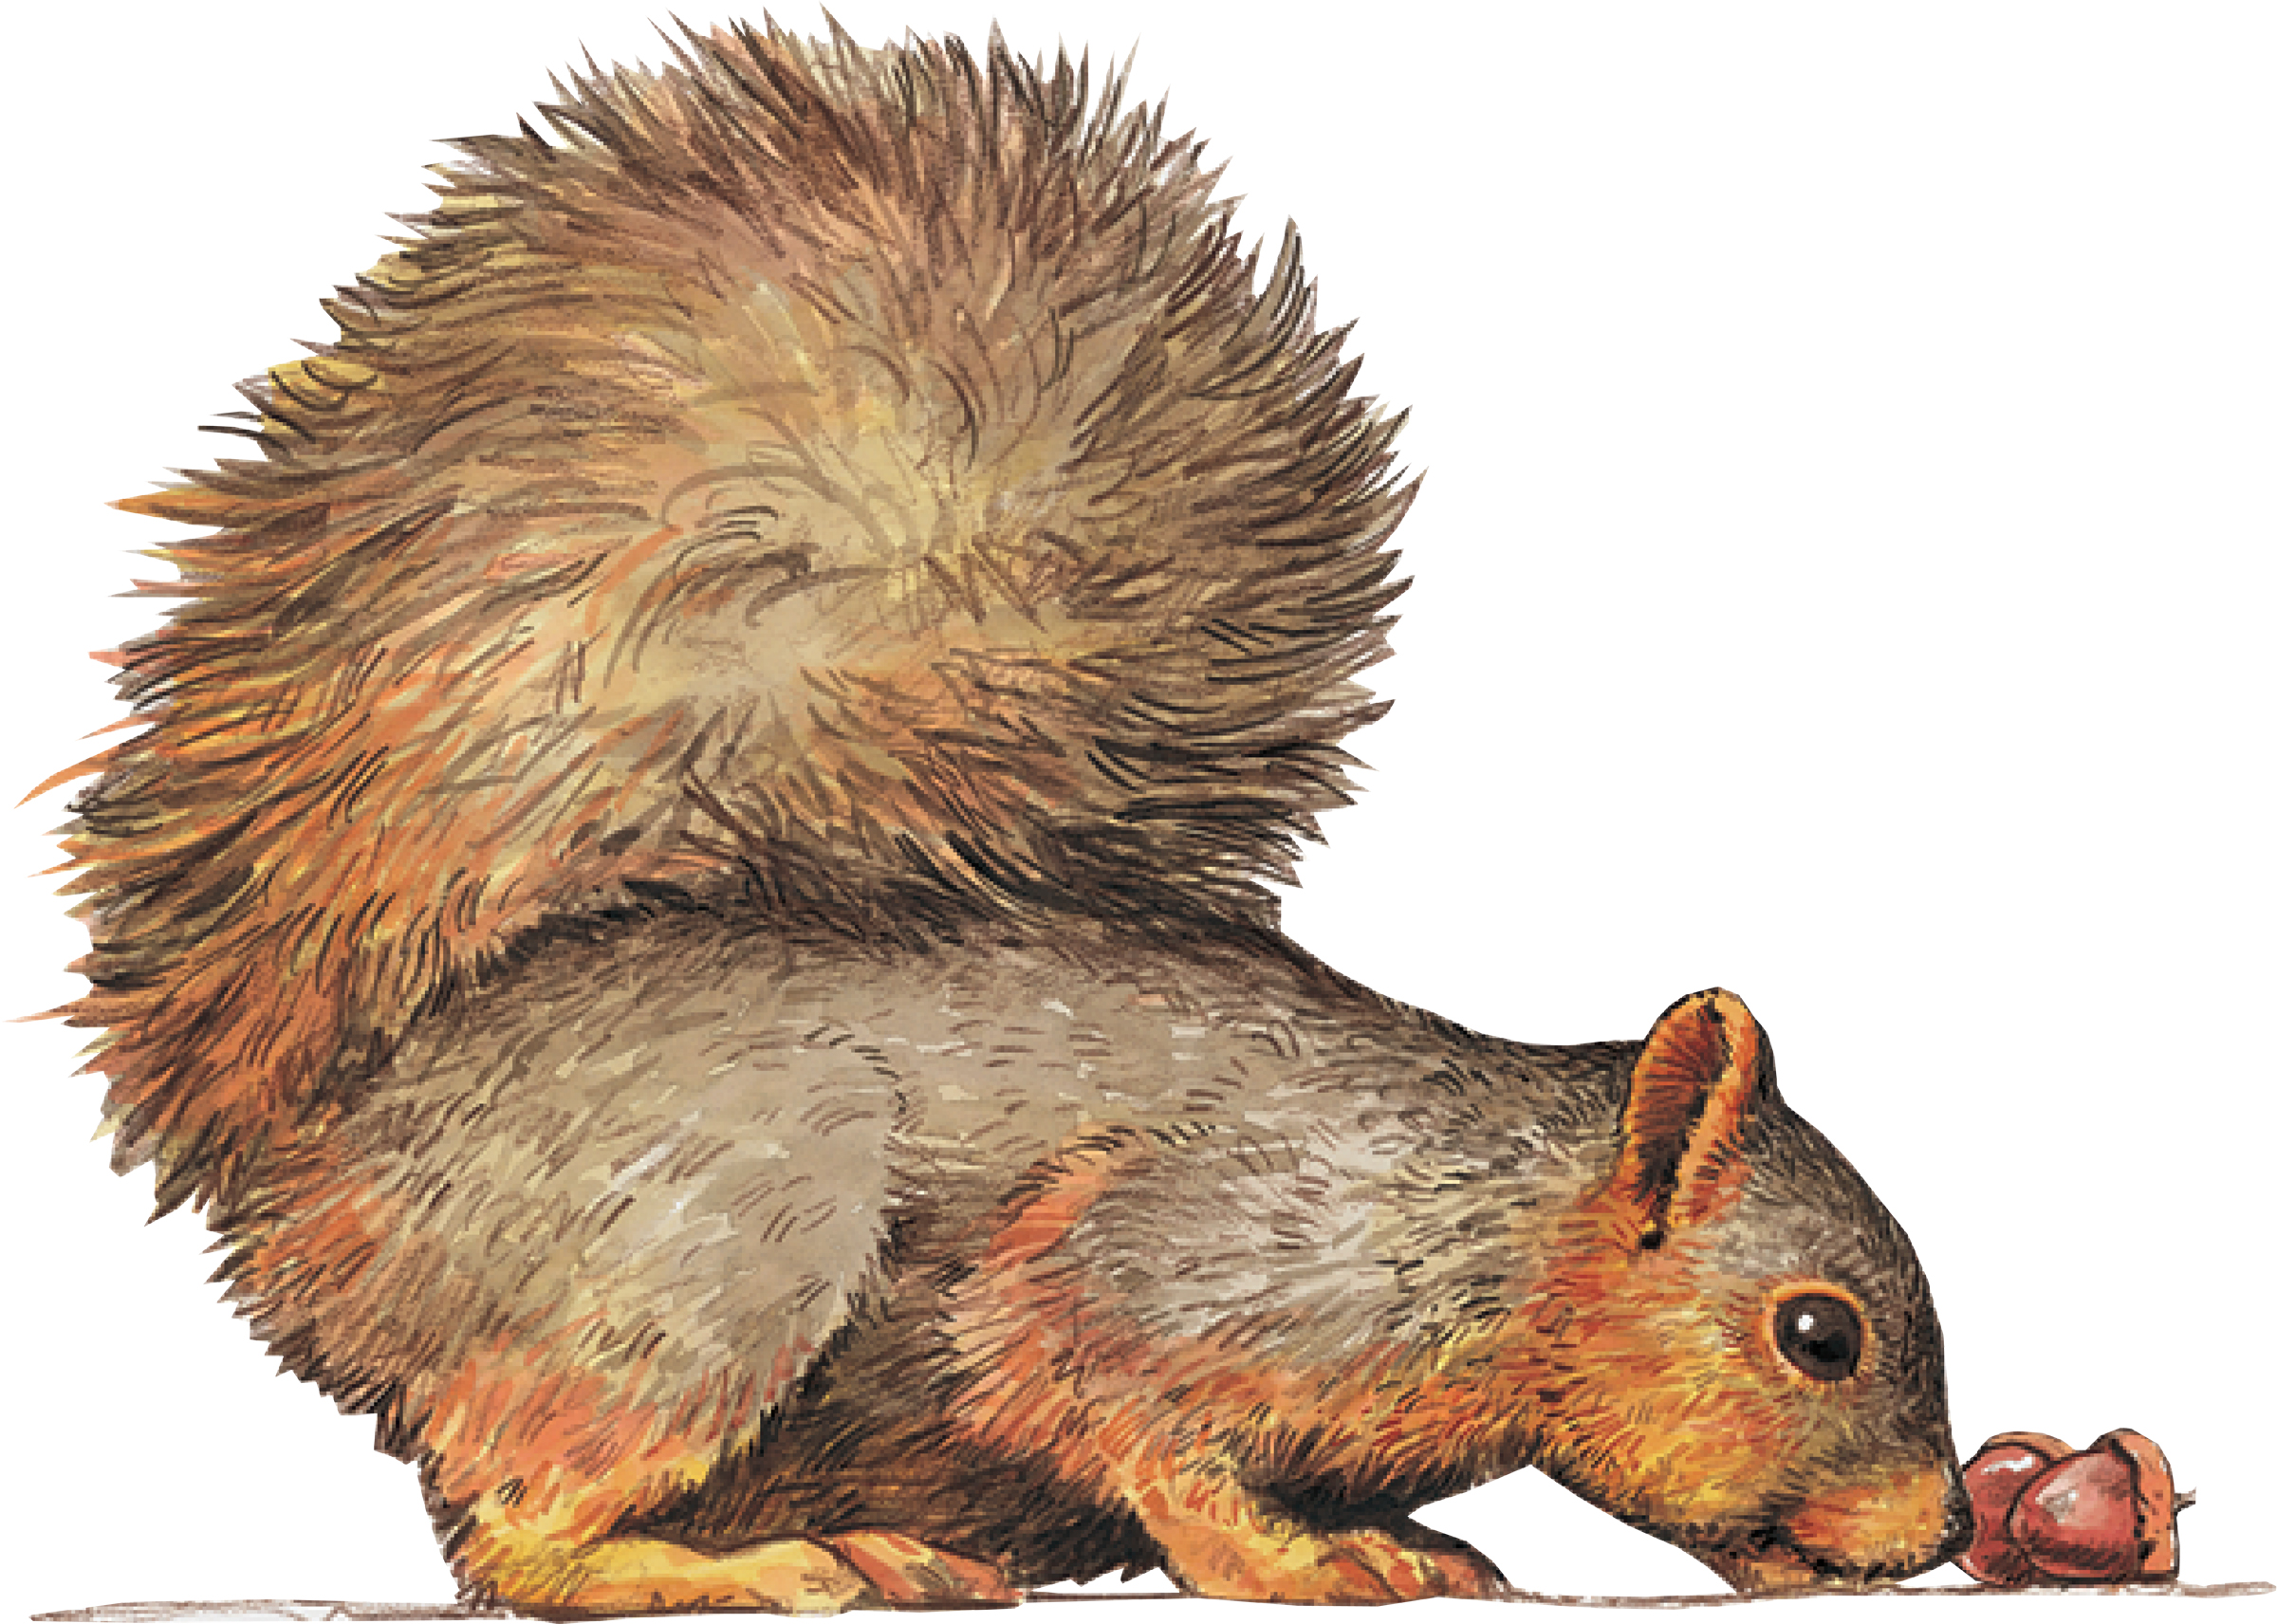 | 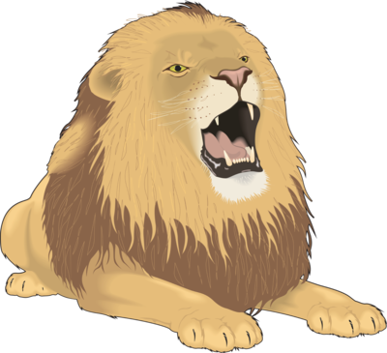 | 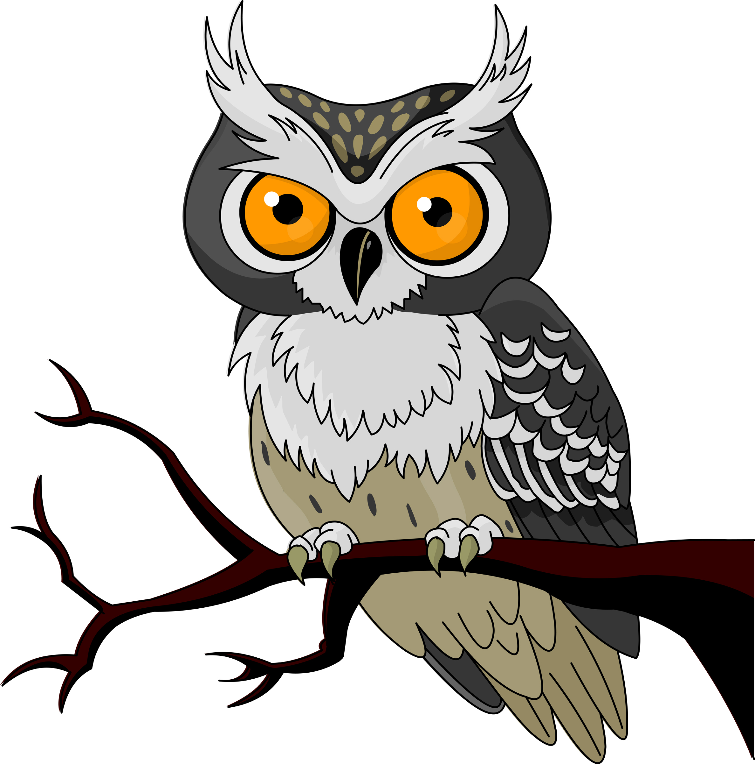
 |  | 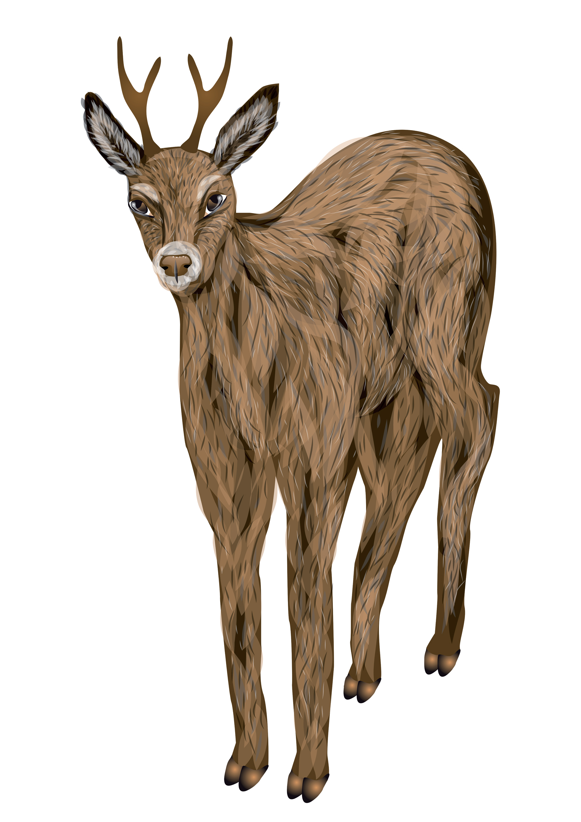
 | 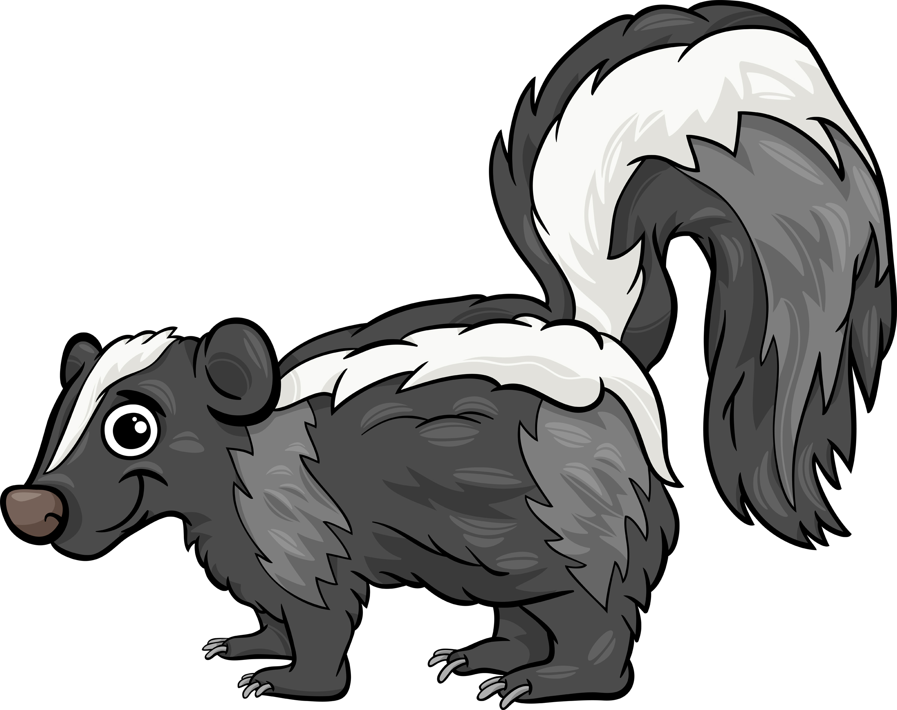 | 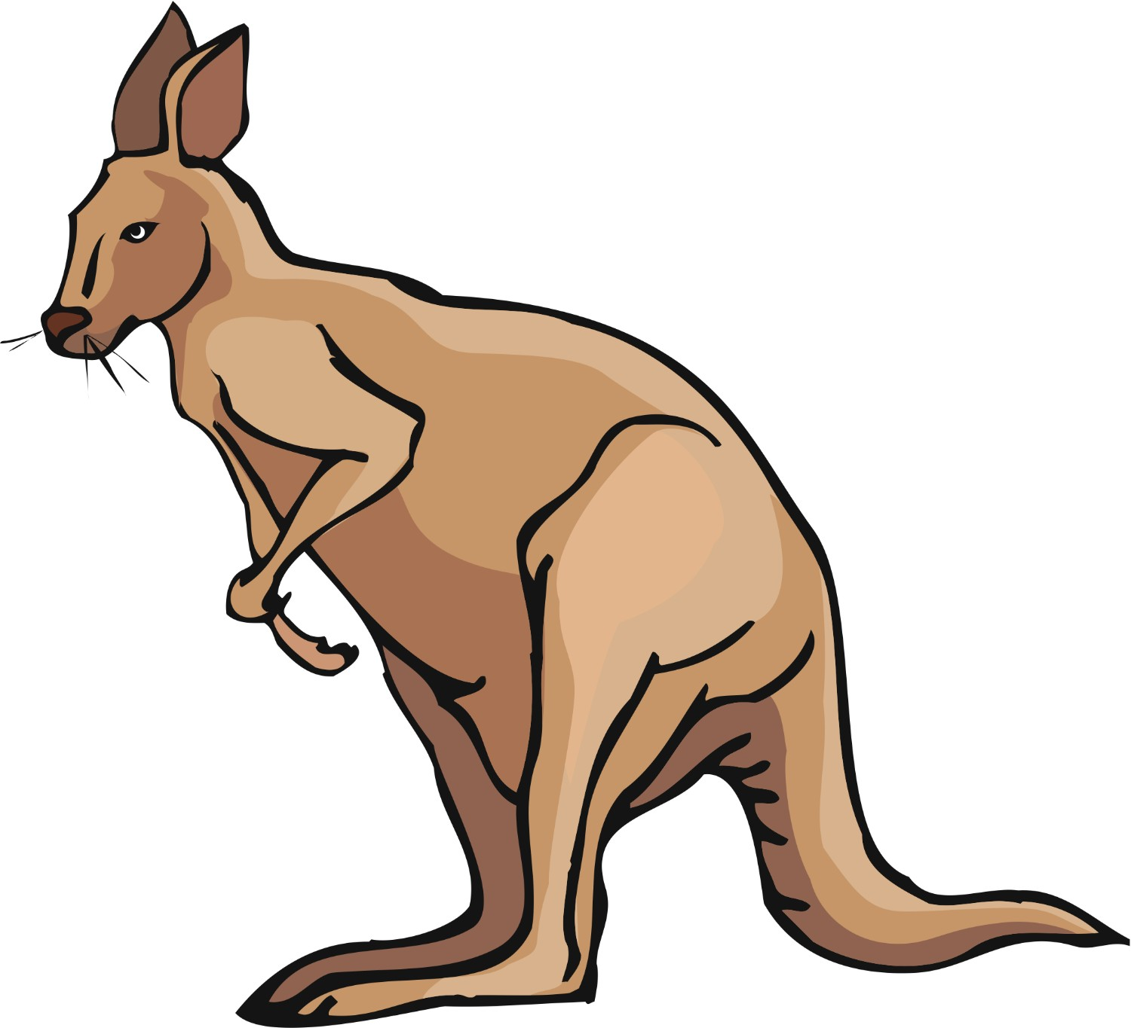
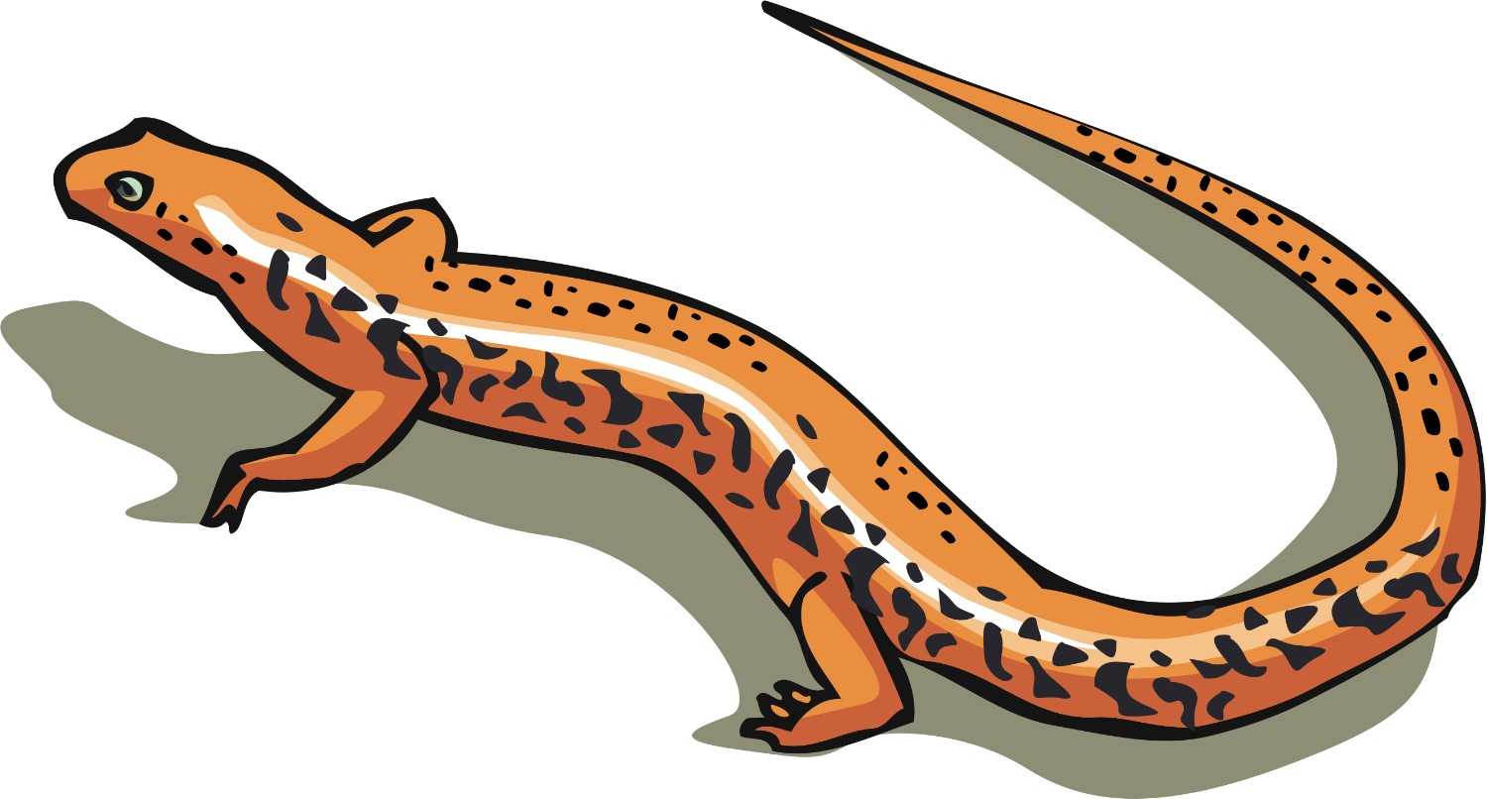 |  | 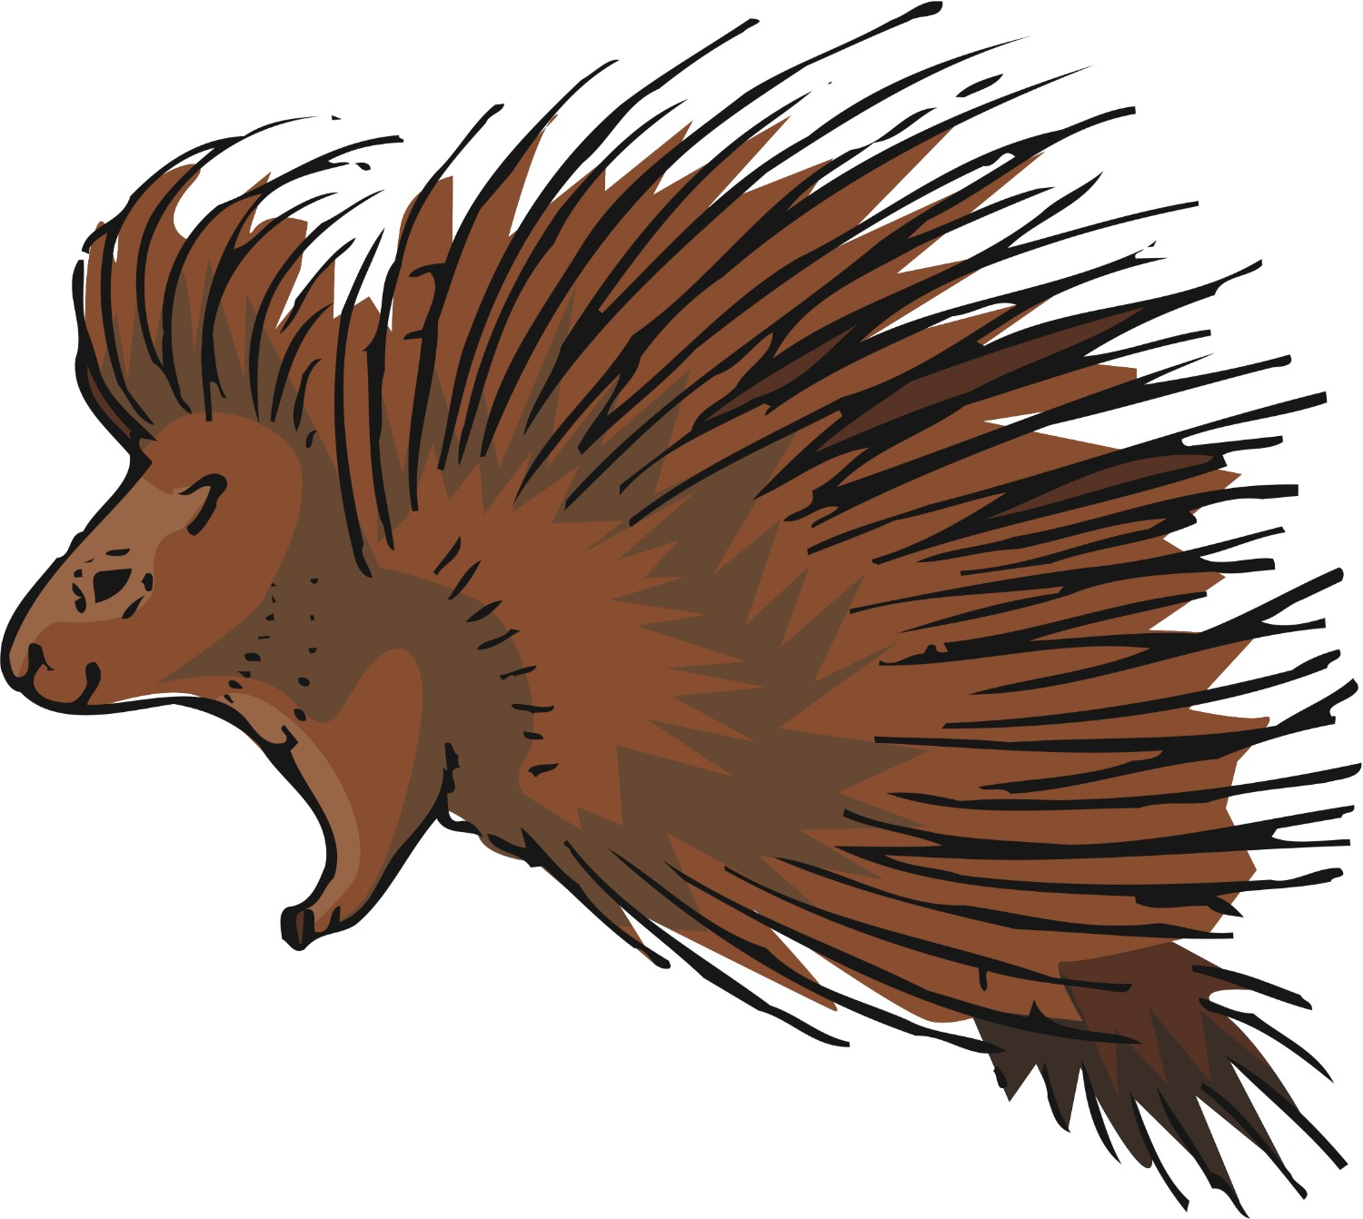

Nocturnal: bat, kangaroo, lion, mouse, owl, porcupine, possum, raccoon, skunk
Diurnal: butterfly, deer, elephant, gorilla, lizard, squirrel

Nocturnal animals are active at nighttime and then sleep during the day. Examples: aardvarks, armadillo, beaver, cockroach, cougar, coyote, firefly, hamster, hedgehog, hermit crab, hyena, jaguar, koala, leopard, lion, scorpion, tarantula, tiger. Diurnal animals are those that are active mainly during the day. Examples: deer, domesticated dogs and cats, elephants, gorillas, hawks, honeybees, humans, lizards, songbirds, and most mammals.

